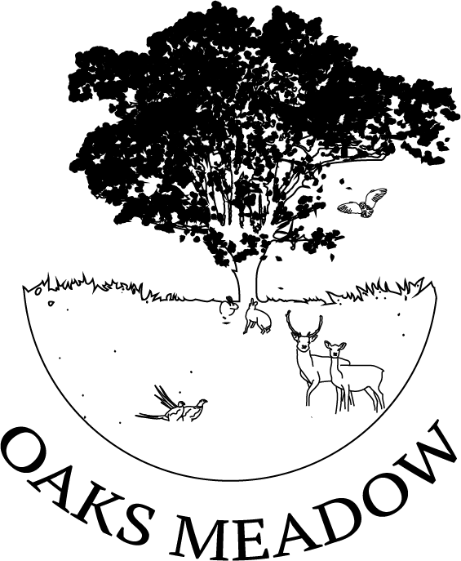

FIVE YEAR
STATEGIC PLAN
2021- 2025
Oaks Meadow Project CIO
Published January 2021
Updated August 2022
Updated November 2023
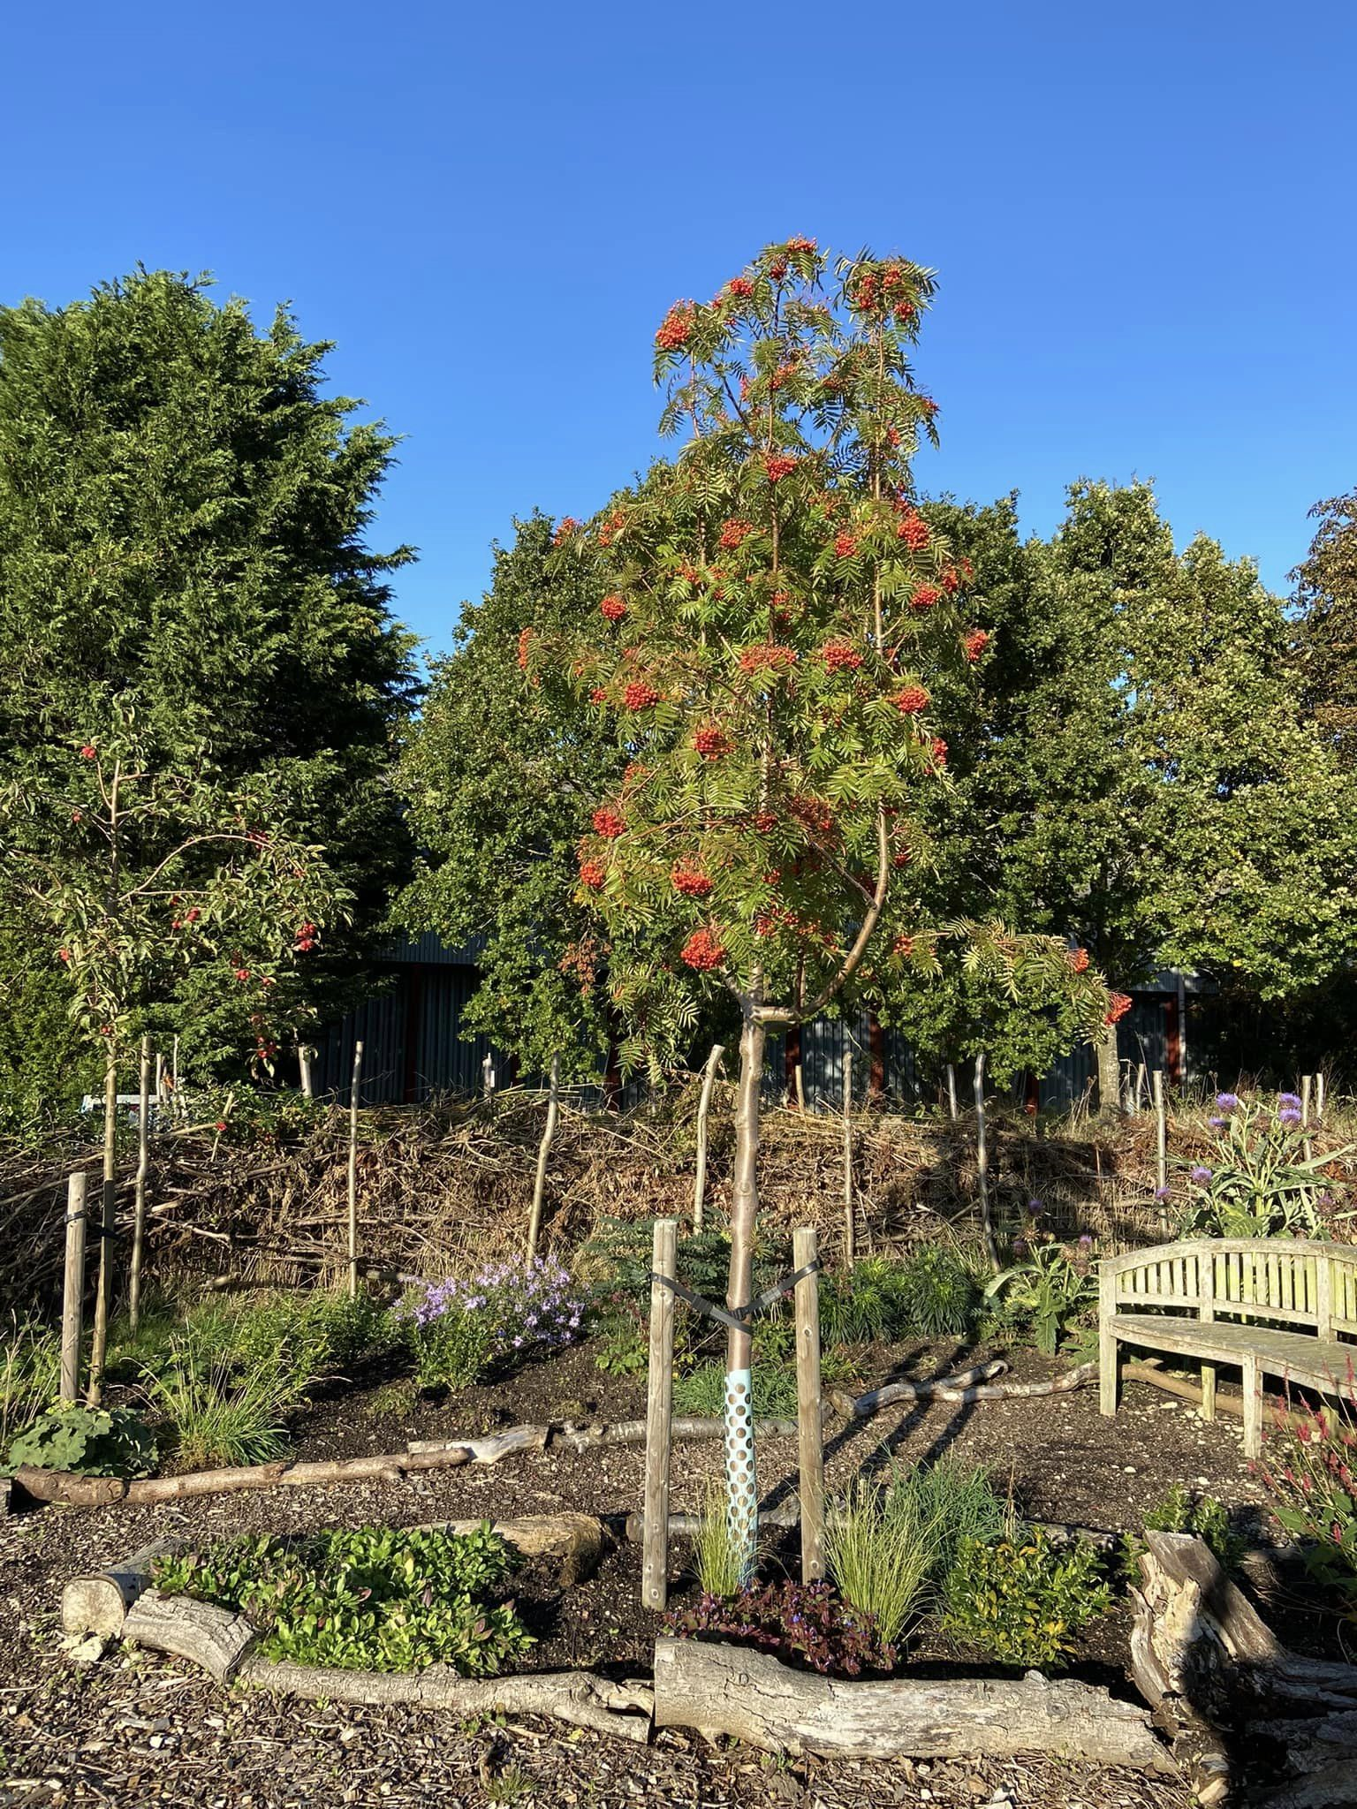

THE OAKS MEADOW PROJECT

OUR FIVE-YEAR STRATEGIC PLAN

2021-2025

PROJECT OVERVIEW
The Oaks Meadow Project is a charity established in 2020 following the generous gift of a four-acre plot of land, on a 50-year lease, for the benefit of the mid Suffolk villages of Combs, Little Finborough and surrounding areas.
The project is working with the community to create and build much-needed facilities in three phases (Phase 1 is ongoing and Phase 2 has been completed)
Phase 1 – A greenspace comprising woodland and orchard as well as vegetable, herb and medicinal gardens and a wildlife pond. Areas for quiet reflection, creative play, learning and community projects will be included..
Phase 2 – A play area to meet the needs of families with children and young people of all ages.
Phase 3 – In the longer term, consideration for an eco-friendly structure providing a community hub for meeting and activities will be explored.
A survey conducted in 2019 by Combs Parish Council provided evidence of strong demand for facilities to help bring our community together and the Oaks Meadow Project is a response to that need.

OUR VISION, AMBITIONS AND VALUES

Vision
A green space with woodland, wildlife pond and horticultural areas, plus a community hub and play area where people can gather together in an environment that fosters learning and wellbeing and provides a base from which, as a community of all ages and abilities, we can support each other.

Ambitions
Our ambitions are threefold:
- to transform Oaks Meadow into woodland, orchard and kitchen gardens with areas for quiet reflection, creative play and community projects
- to create an area for structured play for children
- to provide a community hub structure as a place where people can meet to pursue the group interests they enjoy and provide community services

Our values
- We are community-led and welcome longstanding residents and newcomers alike. We believe everyone has a role to play, should they wish, regardless of age and ability in helping to create new facilities for the benefit of us all.
- We seek to enhance the natural environment to encourage and protect wildlife, and mitigate the effects of climate change wherever we reasonably can.

MESSAGE FROM THE CHAIR OF THE TRUSTEES

Over the years Combs has lost all facilities including the village school, the Post Office and shop, the Live and Let Live and the Gardeners Arms pubs. Little Finborough never had any amenities. This had left our community with no indoor or outdoor facilities in which to gather together and socialise.

Oaks Meadow, once part of Fenn’s Farm, was transferred to me by Victor and Daphne Scarff in 2005. The village fete was held there for 11 years as was the occasional celebration, such as the Combs village school reunion and maypole dancing, but otherwise the meadow had stood bare and desolate. It has been my privilege to lease this meadow to the Oaks Meadow Project to provide a lasting legacy to the villages for future generations and to reduce our carbon footprint by doing our bit to offset climate change.
The Covid lockdowns showed us how important strong communities are and how much people value local green spaces. Oaks Meadow fits well with that spirit of community revival.
An original concept plan produced at the beginning of 2021 was soon acted upon with the help of local volunteers and in collaboration with a range of organisations. To date this resulted in the planting of woodland and hedges, the digging of the pond, design and construction of a reflective space garden, planning and planting of our orchard, a vegetable garden, the installation of composting toilets and a fully equipped play area.
If you would like to know more or if you feel you can support this exciting community-led project through funding, joining our volunteer teams or in any other way, we would be delighted to hear from you.

Desiree Shelley

Oaks Meadow in poetry (Extracts from a poem by Dean Parkin, Suffolk Artlink)

In summer the wildflowers  Pop up here everywhere,  And in autumn the trees  And hedges turn every colour.  In winter the wind rustles  The branches and the meadow,  Bare and cold, looks good in snow.  It’s in the spring  Covered in dandelions  The meadow turns gold. | It’s where we’ll all meet  And this is the plan – the square  Is a new village hall, the circle  A play area, and at the top  Of the field, the oval pond.  Quiet but busy, won’t be noisy.  Somewhere to wander,  Take the dog for a walk, a place  Where people find themselves  And an oak tree for all seasons.
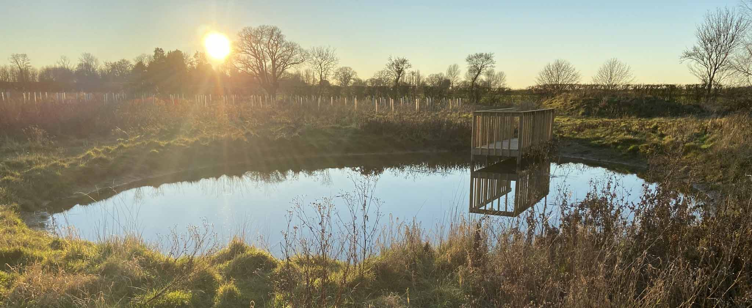

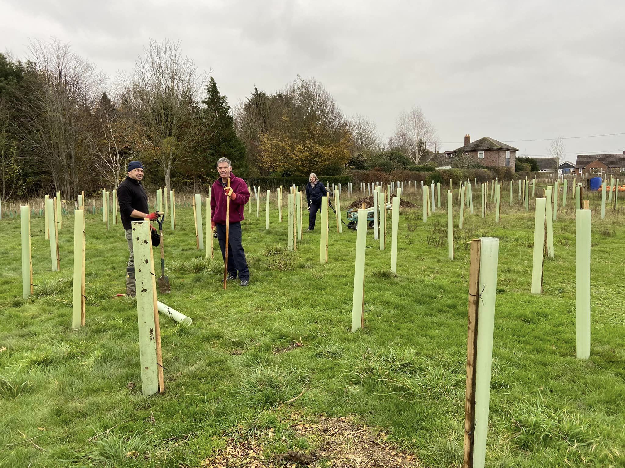

ABOUT COMBS AND LITTLE FINBOROUGH
The Parish of Combs is in mid Suffolk, south of the market town of Stowmarket. The Parish’s population is 852 (ONS Parish Population estimate 2017) and includes the rural villages of Combs and the hamlets of Moats Tye and Little London. Little Finborough is a small neighbouring village with a population of approximately 57 (excluding minors, Electoral Register 2019-20) .
Aside from the Battisford Cricket Club’s pavilion in Moats Tye, the villages currently have no indoor or outdoor amenities or shops, pubs or cafes. The combination of these factors and dispersed, ribbon development make it difficult for people, particularly newcomers, to meet and identify as a community.

Age breakdown for Combs Parish (ONS 2017)
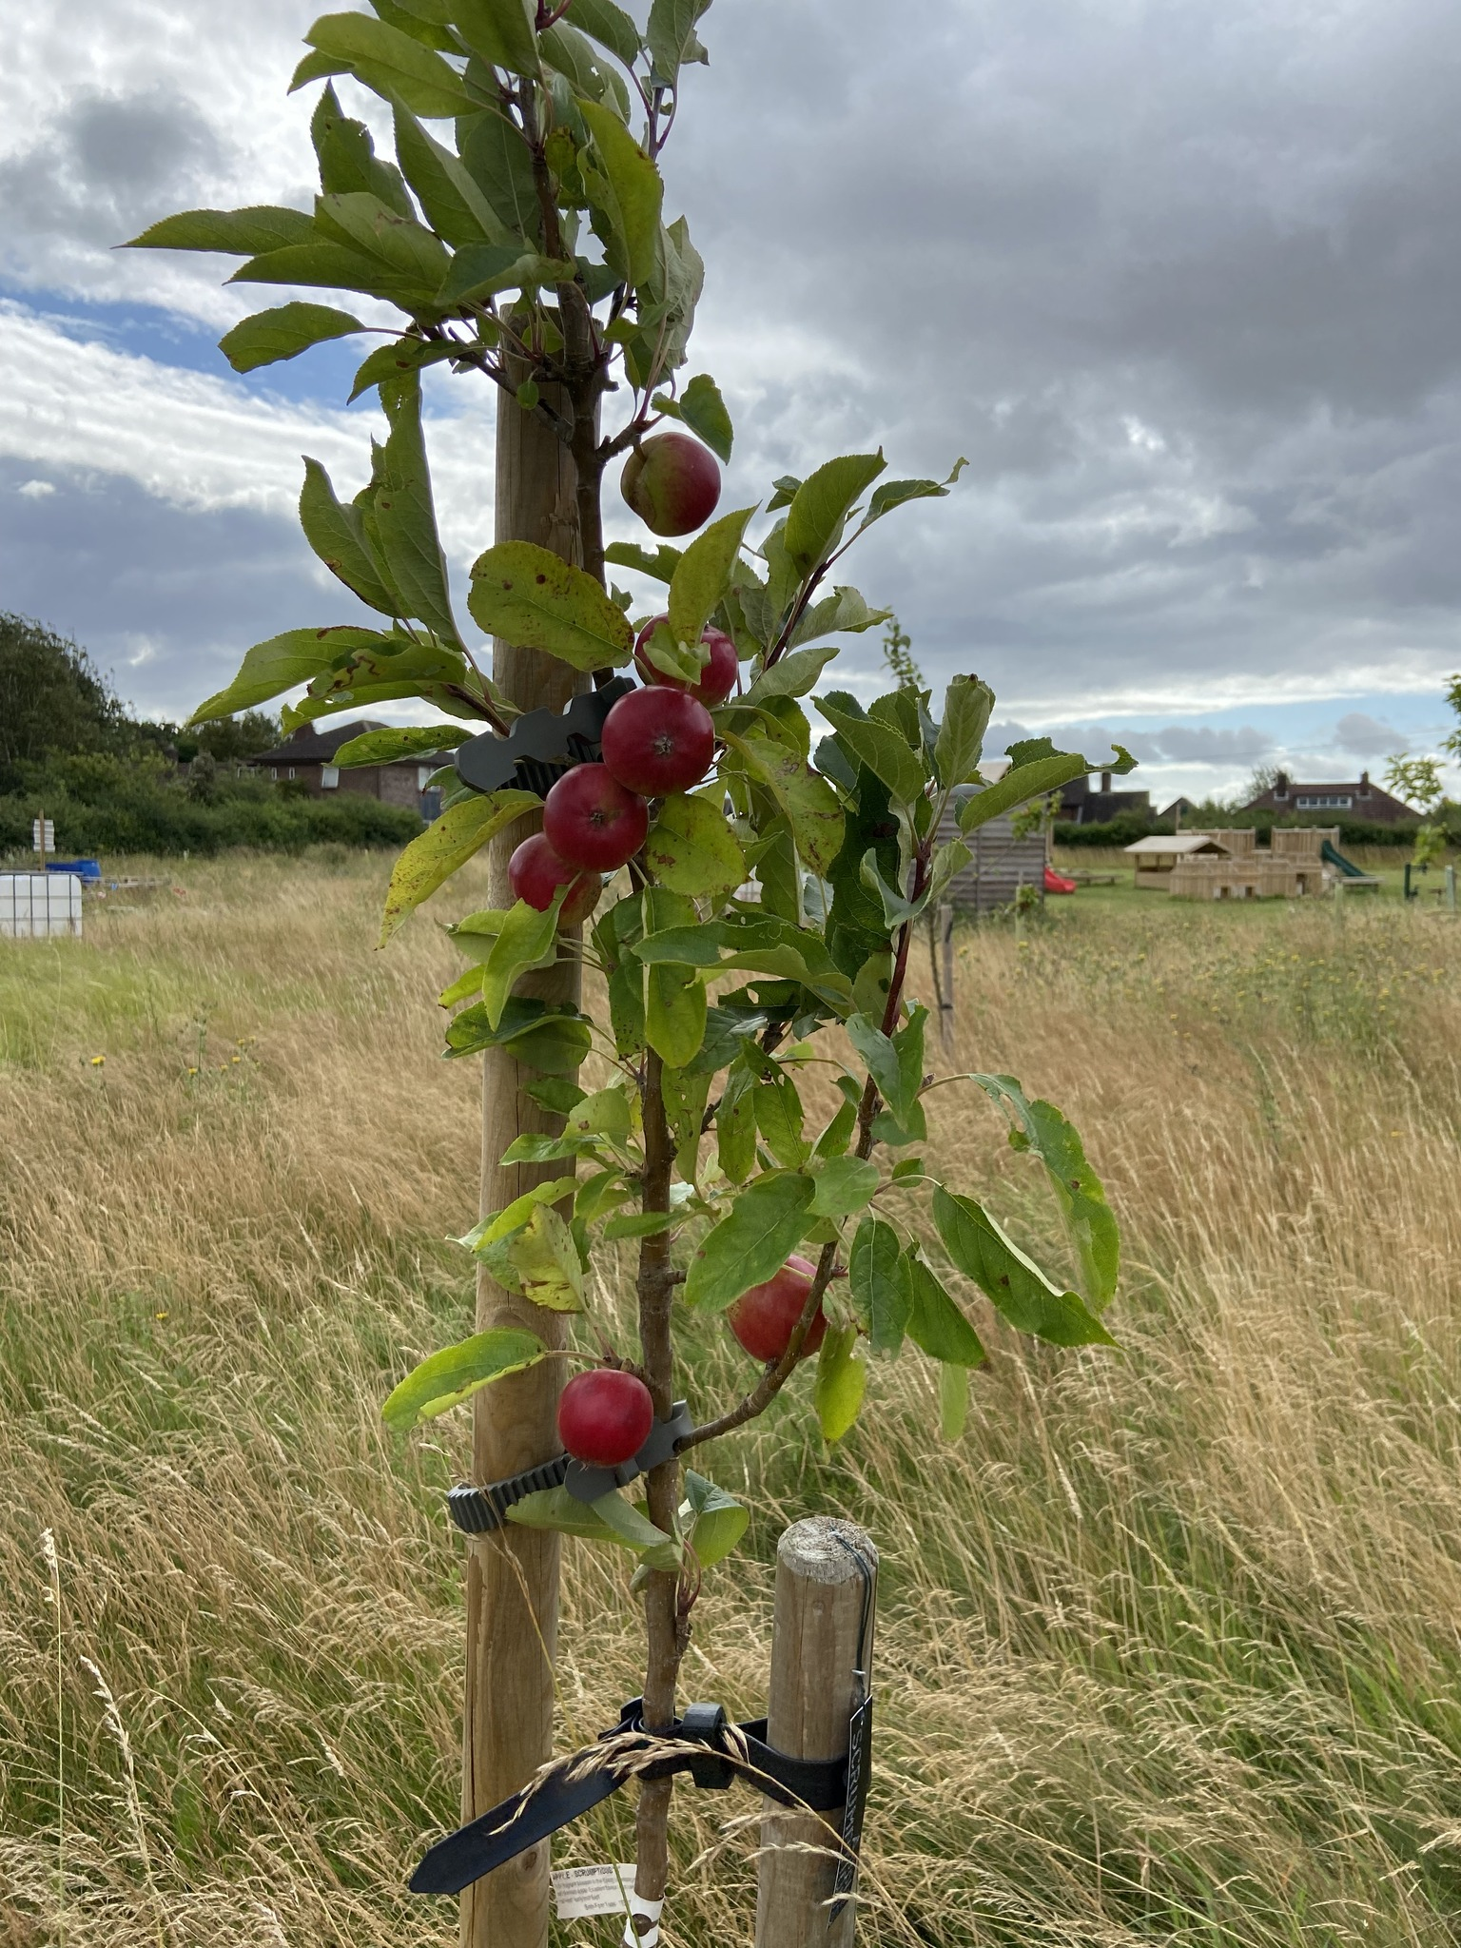
Age group | Number | Percentage
0 to 11 | 57 | 6.6
12 to 18 | 59 | 6.8
19 to 29 | 84 | 9.7
30 to 49 | 174 | 20
50 to 64 | 284 | 32.7
65 to 79 | 175 | 20.2
80+ | 35 | 4
Total | 868 | 100%

From this data we can see that approximately 13.5% are children and young people under the age of 18, 62.5% are of working age and 24.2% are over the age of 65.

COMBS PARISH SURVEY 2019
The vision and ambitions of the Oaks Meadow Project are closely aligned with the results of a comprehensive 2019 survey conducted by Combs Parish Council. Some of the key findings are extracted below:
While the majority of people who responded (one third of households) plan to stay in the area a significant number were thinking of leaving because of:
- a lack of village facilities
- no village hub
- worries about health and old age.
The respondents told us that the top three village improvements the community would like to see are:
- heritage tree planting
- community space to sit and meet
- a play area for young children.
These are some of the groups/clubs and amenities people told us they would like to have:
- a choir, music lessons and reading group
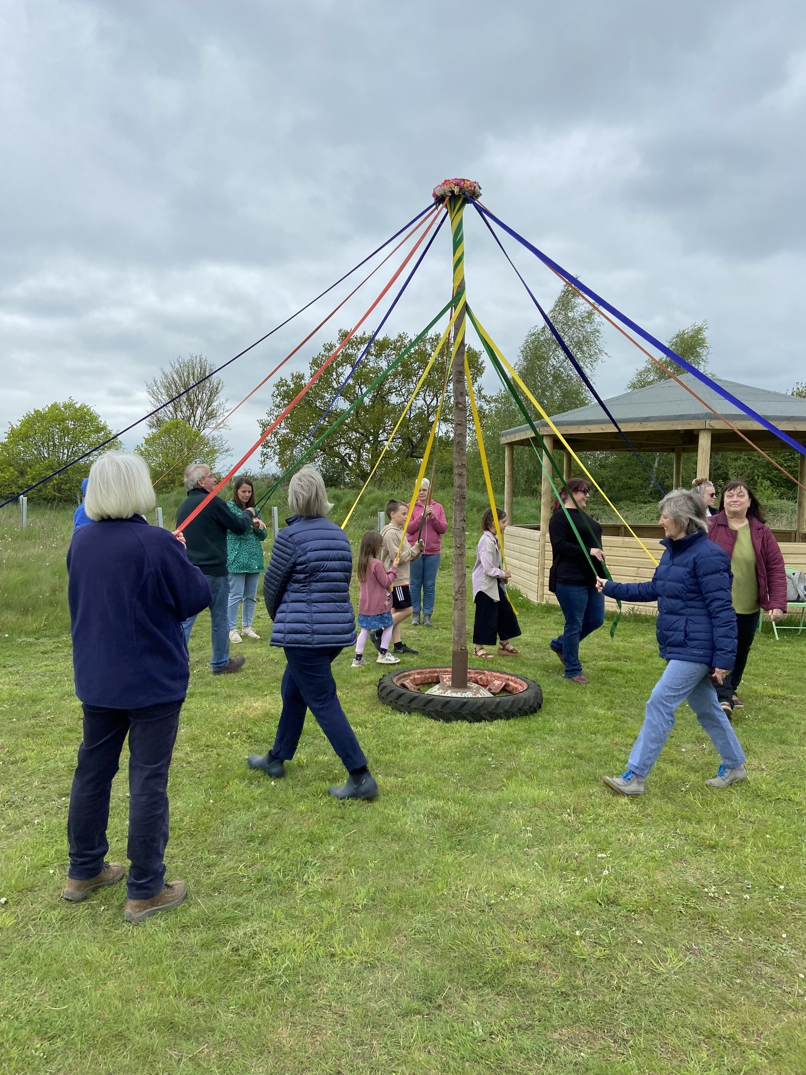
- arts and crafts and pottery
- woodwork and rural skills
- keep fit, Pilates and yoga,
- tennis, bowls, golf and over 50s netball
- a pop-up shop and pub
- allotment space.
Maypole dancing on the meadow

COVID 19 IMPACT
The Covid pandemic highlighted the needs of isolated and vulnerable people and also rekindled our sense of community.
The response to the Combs Parish Council’s call for volunteers to provide a support service during lockdown 1 clearly showed we are a community that cares. It also supports the case for a community hub from which ‘gateway services’ for the elderly and vulnerable might be delivered (see Reducing isolation and loneliness).
Lockdown led to many more people working from home and seeking regular outdoor recreation and exercise. While we have an abundance of well-used footpaths, we had no public open space and, again, this is a need that the Oaks Meadow Project is meeting.

PROJECT BENEFITS

Our ambitions in Phase 1 are to establish a green space with woodland, orchard, wildlife pond, kitchen gardens, composting toilet and areas for creative play and gatherings. In Phase 2 we have created an area for structured play for children and young people and, in Phase 3, we hope to build an energy efficient community hub. The benefits are multi-faceted and include:

Rebuilding a sense of community
The provision of indoor and outdoor spaces where we can gather together for classes, projects, social activities and celebrations will help to increase community cohesion. These facilities will enable people to do more in their own village, make new friends and be aware of and receive support should they need it.
Our project is community led and will, in large part, be delivered through the efforts of local people. We already have a strong body of volunteers of all ages who are giving their time and talents in a wide variety of ways from planning and fundraising to tree planting, grounds maintenance and plumbing. Also see Community involvement.

Reducing isolation and loneliness
In dispersed rural populations such as ours there is a risk that people, particularly the elderly, may lose human contact almost entirely. Tighter-knit, more cohesive communities reduce isolation.
A growing body of research suggests that social isolation is damaging to both physical and mental wellbeing. Public Health England says that loneliness can increase the risk of premature death by as much as 30 per cent. A major barrier to social connection for many people in rural areas is simple physical isolation. One crucial step to fighting loneliness is what the national campaign to End Loneliness calls ‘gateway services’. These are opportunities created within the community for older or vulnerable people to develop new social connections, enhance face-to-face relationships and be part of a real and identifiable community of neighbours.

Health and wellbeing
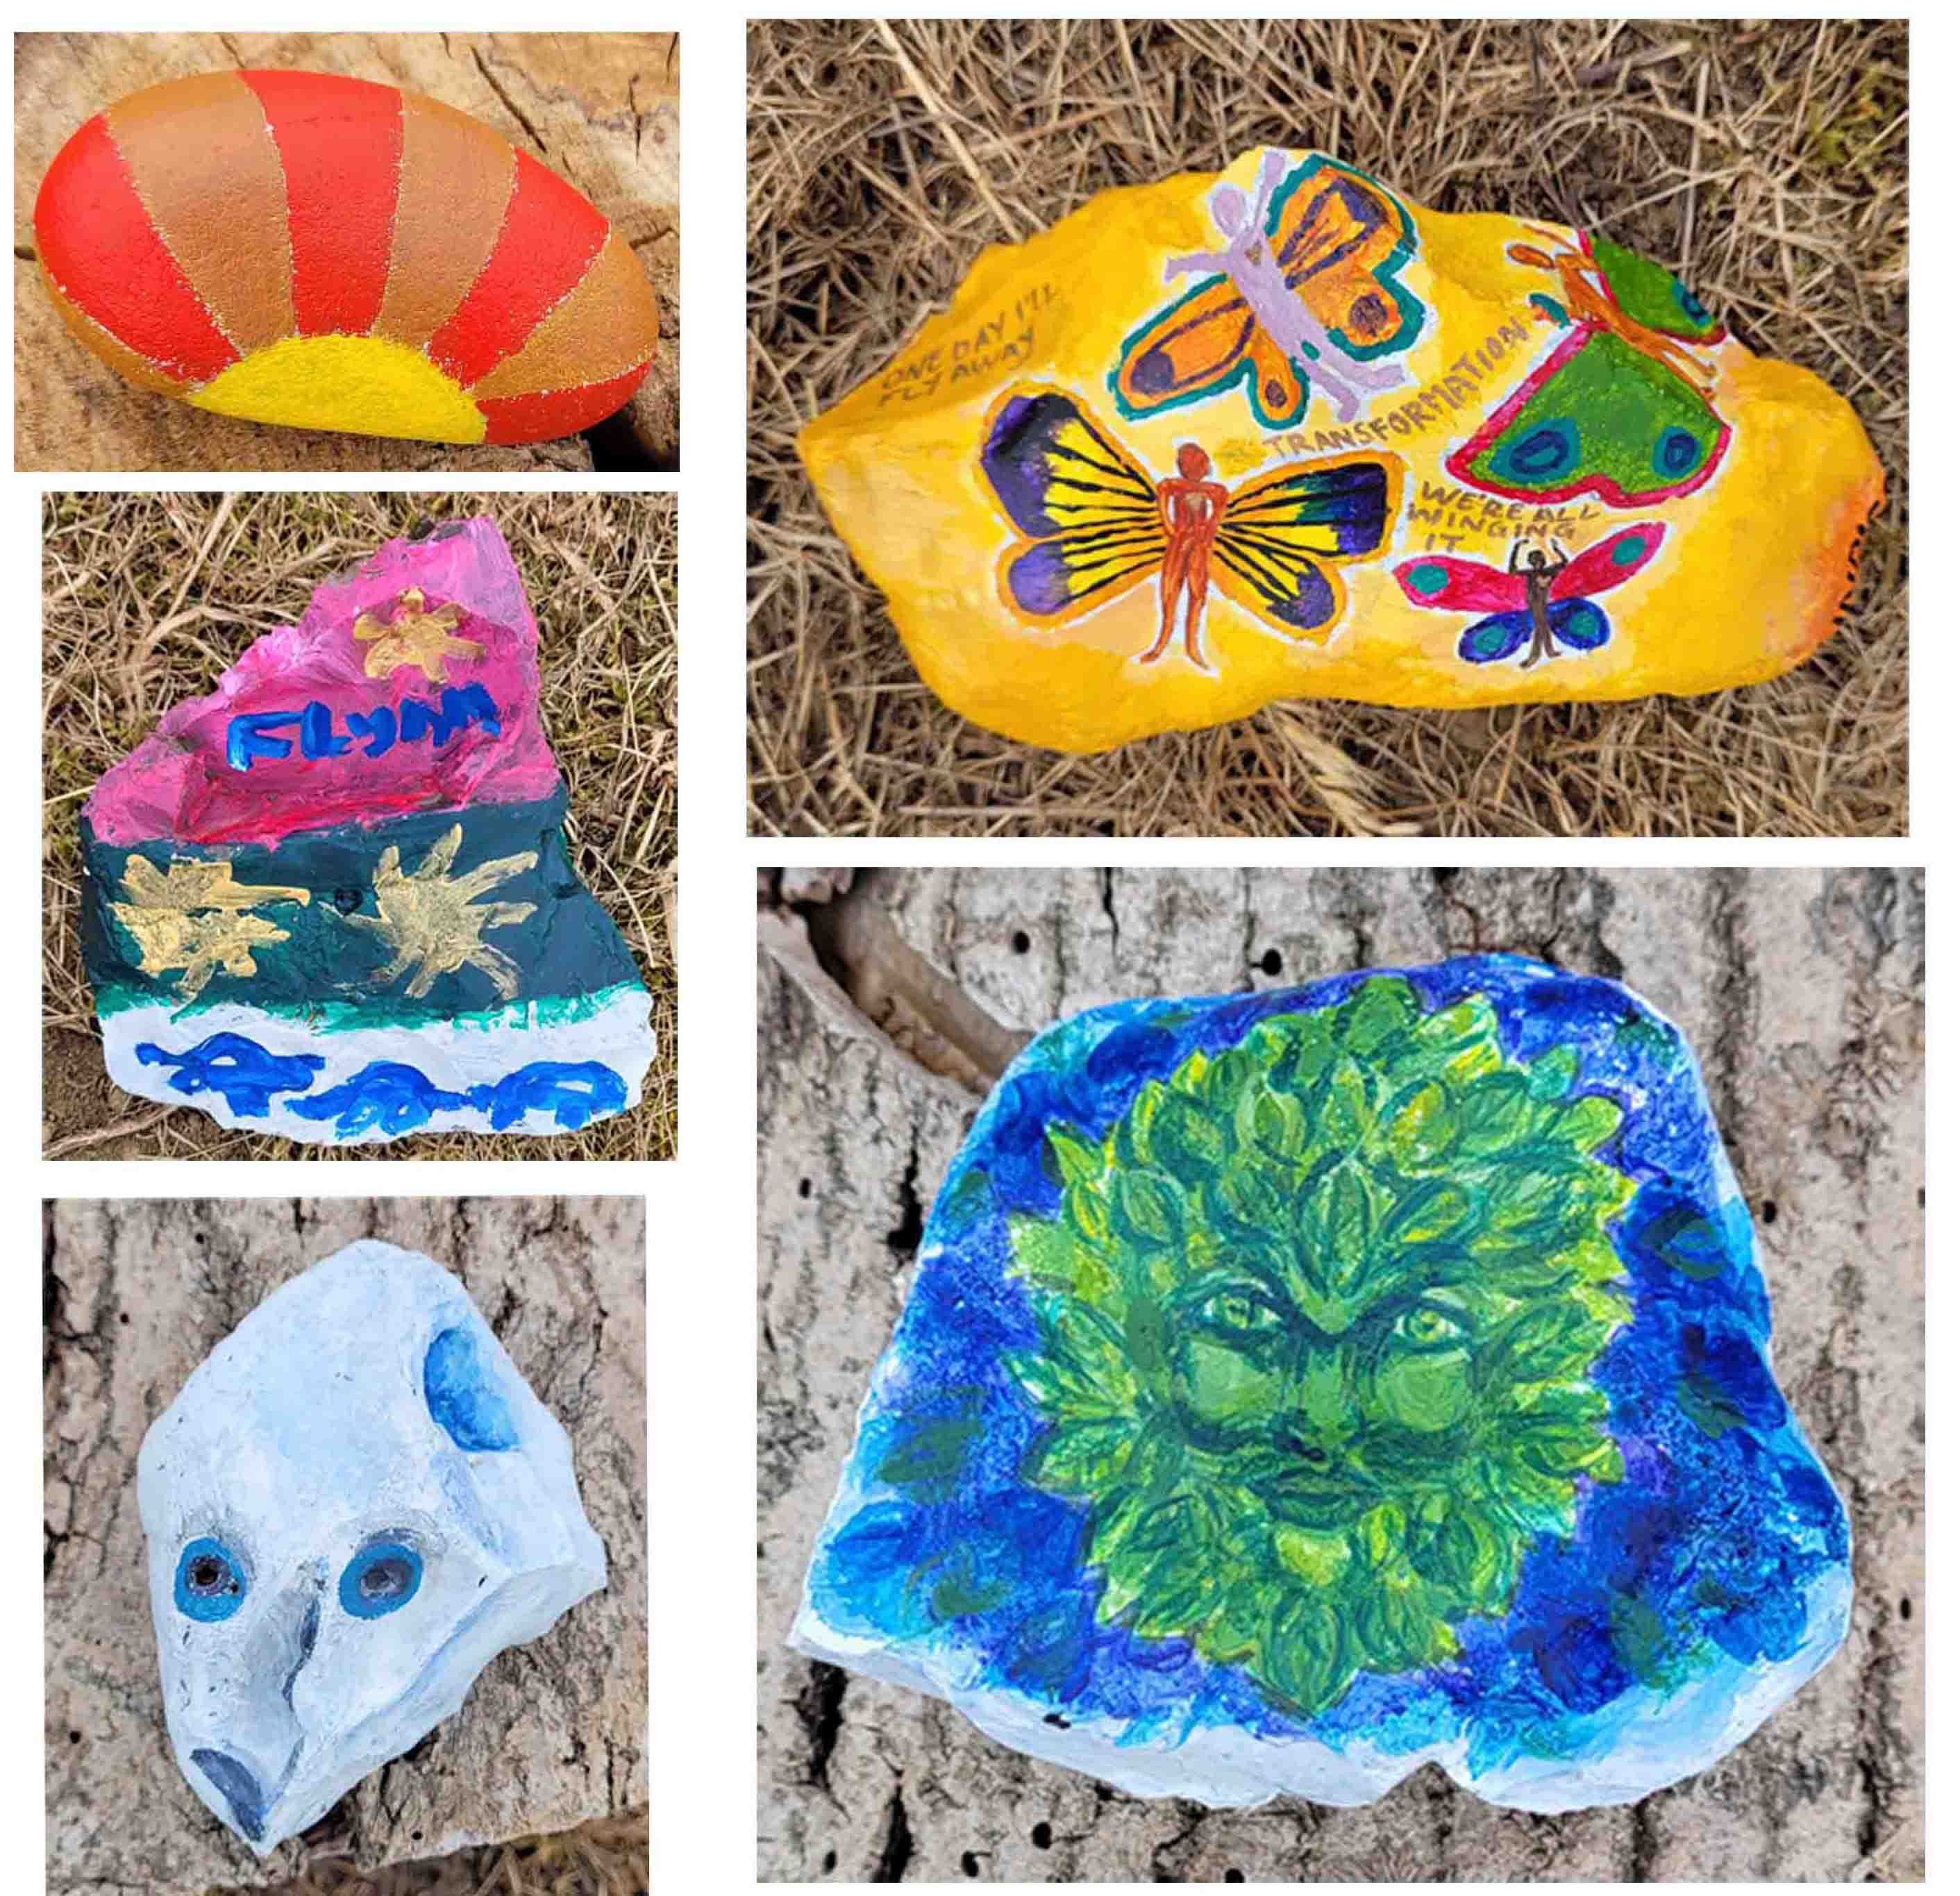
These benefits encompass both physical and mental health and wellbeing. The green spaces provide opportunities for healthy outdoor activities both in the planting and maintenance of the woodland and gardens and in the ongoing enjoyment of them as places to walk, play, relax and take part in outdoor projects and events.
A community hub structure would provide facilities for indoor health and fitness activities such as yoga and Pilates. Special interest groups and social gatherings would enable people of all ages to feel part of a caring community where people help and support each other.

Learning and sharing knowledge
There is a strong learning element to our project. Many people have lost touch with the land and the project aims to help children and young people, in particular, to understand where their food (and some medicines) come from and how they are grown and used. There is a multi-generational aspect as the vegetable and herb gardens will provide a way for the older more experienced gardeners in our community to share their considerable knowledge and expertise.
We are lucky to have a large site which enables us to get local schools, colleges and educational groups involved with, where appropriate, a dedicated area of land they can design, plant and tend themselves. Also see Key supporters and partnerships .
The provision of a community hub structure would have the obvious benefits of enabling a wide range of learning events and classes, for people of all ages and abilities, to take place within the community.

Environment and biodiversity
The Oaks Meadow natural environment is being enhanced with the planting of new woodland, orchard and gardens and the establishment of the wildlife pond. With a four-acre site we are able to increase biodiversity and create spaces where wildlife can thrive alongside areas for public recreation.
Green spaces serve important societal functions with unlimited economic value. For example, as well as contributing to health and wellbeing, woodlands absorb pollution and lock up carbon which in turn cleans our air. These functions benefit rural societies as a whole and help reduce costs on wider communities and local authorities.

COMMUNITY INVOLVEMENT
We are delivering Phase 1 of our project mainly through the efforts of our dedicated community volunteers. They represent people of all ages and backgrounds and bring a formidable range of experience and skills. They are already supporting the project in many ways including:
- As trustees and / or members of project-specific groups
- Organising and taking part in engagement activities (e.g. focus groups and surveys) to ensure our project is community led at every stage
- Fundraising and financial management
- Participating in working parties to clear, prepare, plant and maintain the land
- Advising on landscape, horticultural and woodland management
- Developing our site designs and planting plans
- Advising and handling planning and regulatory matters
- Project management and health and safety and risk assessment.

STRATEGIC GOALS

GOAL 1 Management, systems and people
Ensure we have effective management and operational structures in place together with supporting systems and policies.
Ensure we have the right people and skills when they are needed and that, whether volunteers or paid service providers, they understand their responsibilities and have the support they need.

GOAL 2 Stakeholder engagement and communications
Consult with stakeholders, including our community, on an ongoing basis to gather feedback and ensure that our project continues to meet local needs.
Ensure our stakeholders are kept informed as our project progresses both of developments and needs.

GOAL 3 Design and planning
For Phases 1, 2 and 3, prepare or commission site plans and designs as well as fully-costed project proposals including, where appropriate, feasibility studies.
Obtain planning permissions as needed and ensure all necessary regulations and safety standards are met.

GOAL 4 Fundraising and financial sustainability
Raise the funds we need to deliver our plans through a mix of community, corporate, major donor and grant-based fundraising.
Ensure our project is financially sustainable and will continue to deliver benefits into the long term

GOAL 5 Delivery
Deliver the Phase 1 green space with woodland, orchard, reflective space and kitchen garden areas and Phase 2 play area for young children.
Discuss further with residents and user groups the feasibility of a community hub in Phase 3
See Appendix 1 for the local and national policy context.

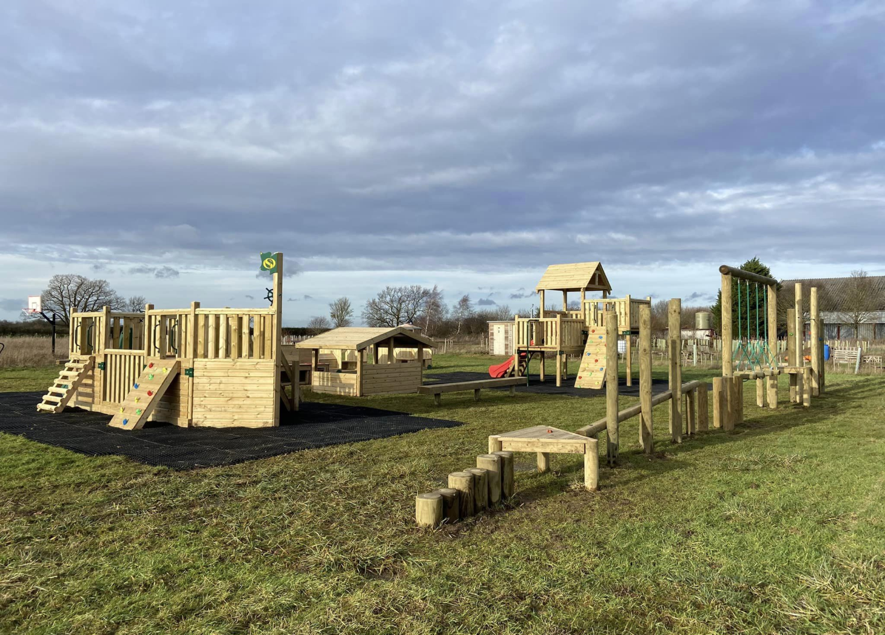

KEY ACHIEVEMENTS (to November 2023)

- Obtained planning permissions for phases 1 and 2
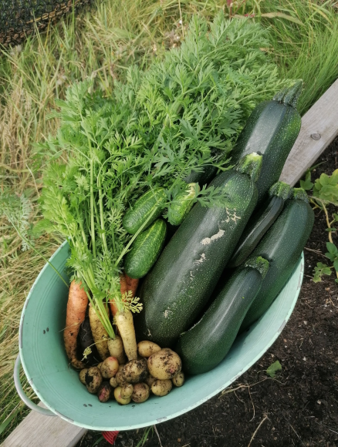
- Planted 500 trees and hedging plants, a community orchard and a vegetable garden.
- Dug a wildlife pond and built a jetty
- Installed composting toilets
- Designed, landscaped and planted out the reflective space
- Installed a new vehicular access, gates and pedestrian bridge
- Installed 4 benches, made from recycled plastic, around the site
- Created a bug house and a hedgehog hotel with the Thrive group.
- Installed a fully equipped play area and a five-metre wide gazebo with seating
- Held an open day, an acorn-themed event, a mid-summer medicine wheel event, an official opening event and May pole dancing in May - all well attended
- Conducted a comprehensive survey to gain local views on how
a village hall/community hub might be used see www.oaksmeadow.org.uk/survey-results
- Installed archways in the reflective garden
- Planting of a sensory garden by the Indigo Opportunities group.
- Constructed a dead hedge around the reflective garden
- Mown pathways through the woodlands and the gardens
- Installation of a wooden litter bin and recycling unit
- Grass cut in preparation for a wildflower meadow
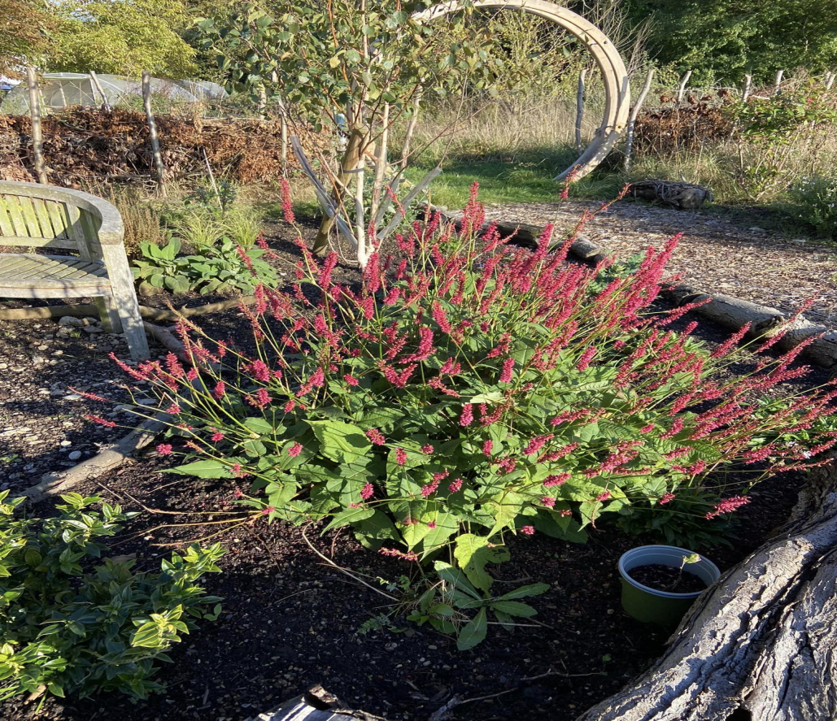

Progress is well ahead of our initial schedule thanks to extraordinary support from the organisations below and others.
Arnold Clark Car Dealership and Geoffrey Burton Trust | Funding for an oak pedestrian bridge
Autism and ADHD Organisation | Design and creation of an area in the reflective space
Combs Parish Council | Funding for oak entrance gates and other support
Higgidy Family Kitchen | Grant to support our vegetable garden
Hoare Trustees of the Clasped Hand Trust | Wildlife pond funding
Indigo Opportunities | Regular attendance to maintain areas in the green space
National Garden Scheme | Funding for archways and plants in the reflective space
National Lottery Community Investment Fund and Ikea | Grant towards landscaping the reflective space
National Lottery Community Fund | Funding for the composting toilets
Mid Suffolk District Council | Third party contribution funding towards the play area and gazebo | Locality budget funding (Councillor John Matthissen)
Sicon Foundation | Supplying trees and helping to plant the community orchard
Suffolk County Council (Healing Woods) | Funding for trees and hedges, benches, signage and professional design of the reflective space | Locality budget funding (Councillor Kay Oakes)
Suffolk New College – Suffolk Rural | Student participation through supervised working parties
The Art of Salvage – Danny Bellamy | Construction of the Jetty, Footbridge, Noticeboards & Entrance Fencing
Thrive at the Mix | Student involvement in various projects including making hedgehog hotels and bug houses
Valencial Communities (Viridor Credits / Landfill Communities Trust) | Funding for the children’s play area and gazebo

None of our progress would be possible without our dedicated community volunteers and
Guardians of specific areas.

NEXT STEPS TIMELINE
By end of 2023 | Further review of village hall/community hub survey findings; determine next steps
By end of 2024 | Further community hub research and consultation related to feasibility, business and sustainability planning
By end of 2025 | Be ready to move forward with community hub delivery subject to research outcomes.

CONTACTS AND FURTHER INFORMATION
If you are interested as an individual, company or not for profit group, club or organisation in getting involved with the Oaks Meadow Project, please don’t hesitate to get in touch.
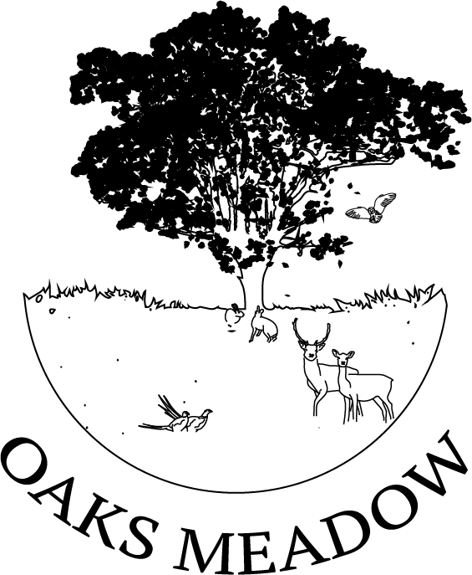
Desiree Shelley
Oaks Meadow Project Lead and Chair of the Trustees
Email: oaksmeadow@gmail.com
Facebook: Oaks Meadow Project
Website: www.oaksmeadow.org.uk
To add your name to our email updates list, please email Desiree Shelley as above.

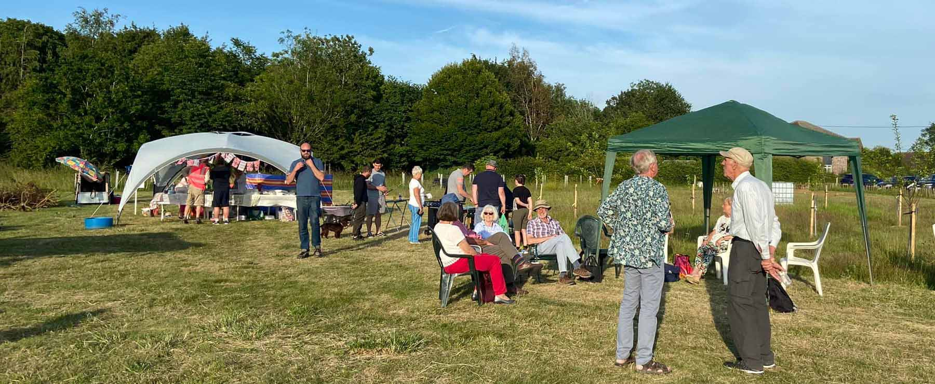

APPENDIX 1

NATIONAL AND LOCAL POLICY CONTEXT
The Oaks Meadow Project aligns with local and national policies including :

1. Joint Local Plan for Babergh and Mid Suffolk (November 2020)

Healthy Communities and Infrastructure:
All of the growth and development needs to be supported by the provision of facilities and infrastructure, such as our transport and water supply networks, health and education facilities as well as our important network of green spaces and community facilities…

The Environment:
Environmental enhancement, protection and management is at the heart of the JLP, supporting the Councils’ ambition to be carbon neutral by 2030. The JLP policies provide a framework to support the transition to a low carbon future in a changing climate, taking full account of flood risk and coastal change. This is to be met through a combination of Climate Change policies including issues on sustainable construction, design, energy, flood risk and water management. They also protect and manage green infrastructure, biodiversity, geodiversity, landscape (including the AoNBs) and the rich historic environment.

2. The Suffolk Nature Strategy 2015
…Access to, and enjoyment of the countryside, is equally important. Physical and mental wellbeing, known to be associated with an accessible and attractive natural environment, are a benefit to business, innovation and entrepreneurship and reduce pressures on social care and health services.
Green space can help to reduce health inequalities…

3. National Planning Policy Framework

Section 15.Conserving and enhancing the natural environment
174. Planning policies and decisions should contribute to and enhance the natural and local environment by:
a) protecting and enhancing valued landscapes, sites of biodiversity or geological value and soils (in a manner commensurate with their statutory status or identified quality in the development plan);
b) recognising the intrinsic character and beauty of the countryside, and the wider benefits from natural capital and ecosystem services – including the economic and other benefits of the best and most versatile agricultural land, and of trees and woodland…
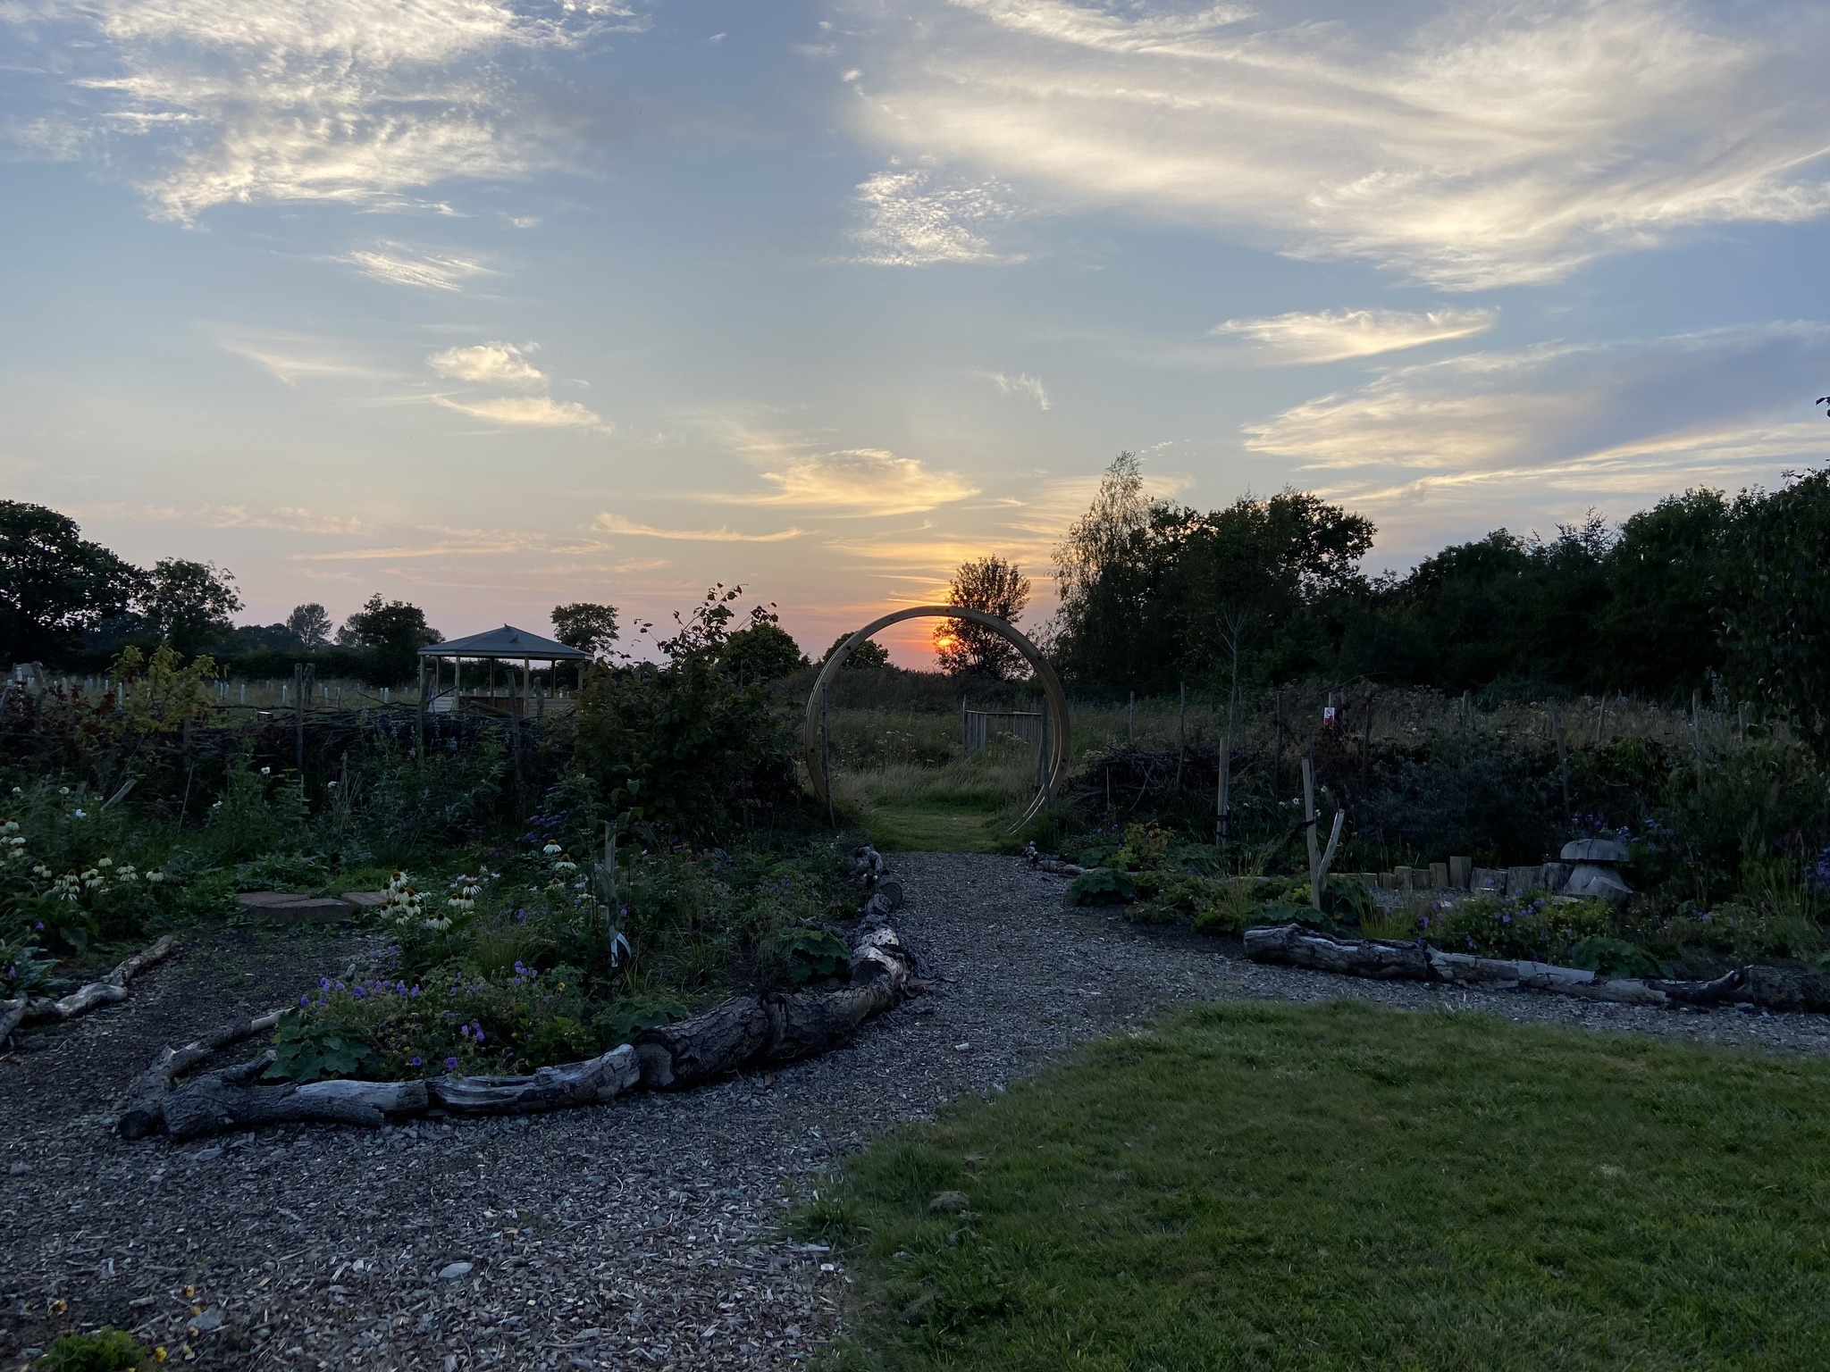

The Reflective Garden with the Gazebo in the background

